Experiment 12: Perspective Transformation on an Image
Software / Tools: Python · OpenCV (cv2) · NumPy

AIM
To apply a Perspective Transformation to an image to simulate a change in viewing angle (does not preserve parallel lines).
ALGORITHM
1. Import OpenCV and NumPy.
2. Read the input image and note its dimensions.
3. Select 4 reference points in the source image (the four corners).
4. Define the 4 corresponding destination points.
5. Compute the perspective transform matrix using cv2.getPerspectiveTransform().
6. Apply the matrix with cv2.warpPerspective().
7. Display and save the transformed image.
PROGRAM (SOURCE CODE)
import cv2
import numpy as np

img = cv2.imread("image.jpg")
(h, w) = img.shape[:2]

pts1 = np.float32([[0, 0], [w, 0], [0, h], [w, h]])
pts2 = np.float32([[50, 50], [w-100, 30], [50, h-30], [w-50, h-100]])

M = cv2.getPerspectiveTransform(pts1, pts2)
perspective_result = cv2.warpPerspective(img, M, (w, h))

cv2.imshow("Original", img)
cv2.imshow("Perspective Transformed", perspective_result)
cv2.waitKey(0)
cv2.destroyAllWindows()

OUTPUT
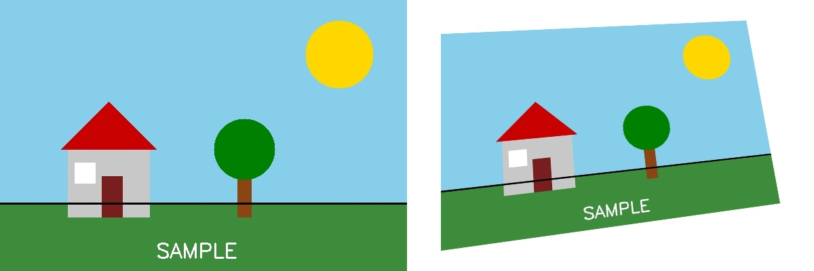
Fig. 12 — Output of Experiment 12: Perspective Transformation on an Image.
RESULT
Apply a Perspective Transformation to an image to simulate a change in viewing angle (does not preserve parallel lines) — completed successfully, as demonstrated in the output shown above.

